# Embrace Your Own Pace!

[Ms.Nikita Vyas](https://www.practo.com/share/app/doctor/575625" \t "_blank)

Psychologist

[View Full profile](https://www.practo.com/share/app/doctor/575625" \t "_blank)

26 March, 2018

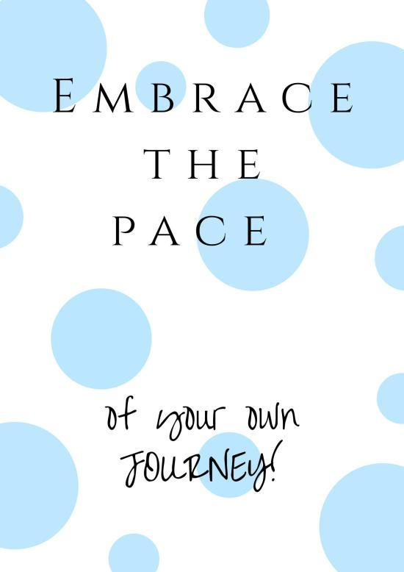

Everybody these days is set out to do something with their lives. Whether its personal or professional, they are always on the move. Where this is a good thing, some people make this one mistake which sets back their speed of success and ruins their confidence.

We take inspiration from many people. Most of them are either extremely successful or at a place that is fairly successful. Without any doubt, we are inspired by them. We try to apply their methods to our journey. We try to understand "how the hell did they manage that?".

Soon we accomplish to do just that. But we still do not get the same results. We do not achieve the same thing that they did. Why? This leads to frustration and anger. Either we stop the work or lose confidence.

**These are the things to follow when on your journey:**

**1. Understand the Inspiration, don't ape it:** Here is the deal. You will never do what someone else did. It is not possible to do so. Every career or life choice is made based on "your motives, your experiences, your thoughts, your feelings", it's all YOU. Which means each inspiration is just a guideline.

**2. Do not compare your life to anyone else's:**This is the basic mistake we all make. In our lives we will meet people who would have gone through the same issues we did/do, they may experience the same feelings, but it does not mean that it is the same thing.

**3. Do not ignore your pace:**Please, Please, Please do not burden your pace by judging it. It takes a long time to reach a certain space in life. If you are slow or too fast please avoid all judgement at any cost. The trick is not how fast you reach but the way you reach. It is not the shortcut but the intelligence and hard work that actually takes you places.